I AM…………………….Digital Story Guides Date: …………………….

Mapping – create a map about the child; what they like and the things they find challenging using the headings below. This will help when planning the filming

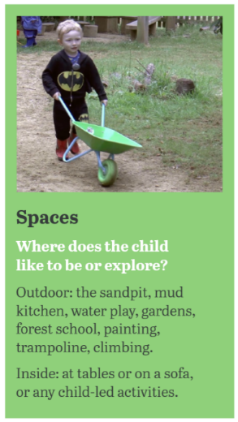

Spaces: -

People & interactions: -

Anything else?

Skills & capabilities

Communication & expression:-

Independence & agency: -

Support: -

Objects & interests: -